YR 9 EURO unit: L’uomo vitruviano
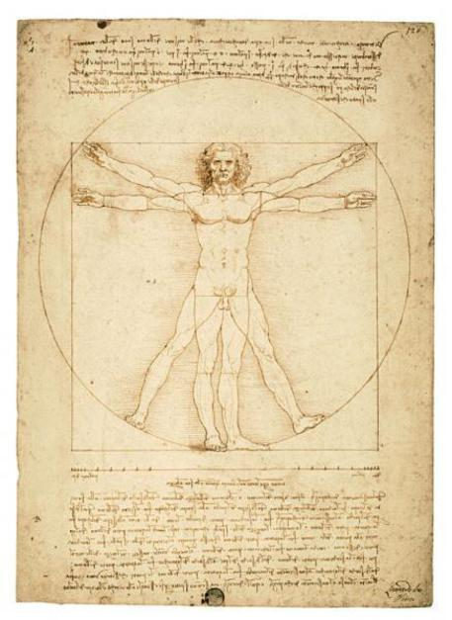
- REFLECT ON WHAT YOU ALREADY KNOW ABOUT THE VITRUVIAN MAN:
Have you seen this image before?
Do you know who drew it?
What do you think he was trying to explain with this picture?

- LEGGETE:
The Images on the Italian Euro coins
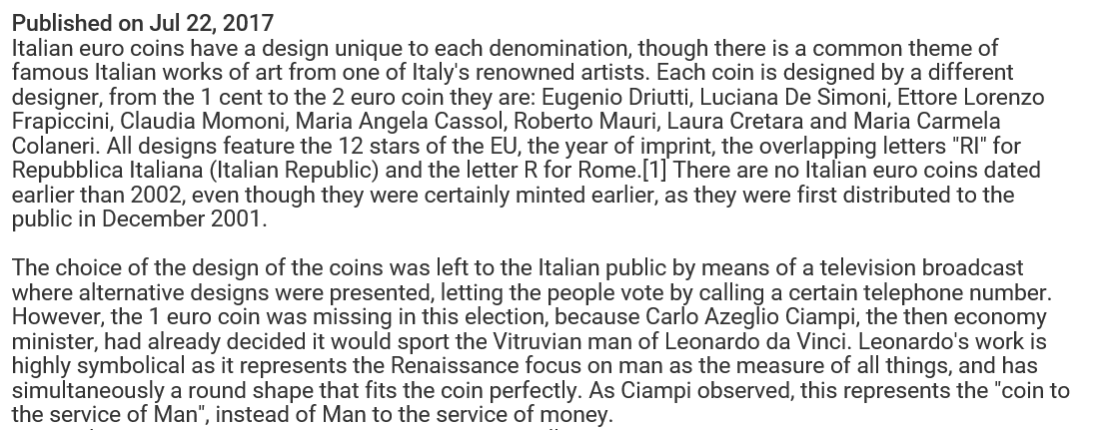
Source: https://www.youtube.com/watch?v=6cCiksF96EQ

- GUARDATE e RISPONDETE:
Watch the video: Leonardo’s Vitruvian Man explained https://youtu.be/rhrst5eSm6I
What does Leonardo’s Vitruvian Man teach us about the proportions of the human body?

- GUARDATE e RISPONDETE:
Now watch this one: Da Vinci’s Vitruvian man of maths https://youtu.be/aMsaFP3kgqQ
Why is this famous drawing so significant?

- RIFLETTETE:
How does this relate to and explain the decision to place the image on the €1 coin? What have you learned?

Video for counting euro & info about euro use
https://www.italianpod101.com/index.php?p=2851&src=alert&e=Angela.Benedetti@smc.sa.edu.au

